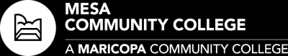

**Associate in Applied Science (AAS) Degree**

**Fire Science Degree Track**

🞊- *Classes must be taken in same semester*

★*- Necessary Course*

🗹- *Critical Course*

*Note: Some FSC classes are held only in the Fall or Spring. May have to substitute electives. 1st semester can swap FSC113 for 119.*

*Note: For classes that are already completed, substitute with a course from the future semester.*

*Note:*